Continuous Integration (CI) and Continuous Delivery (CD) are practices that help move code from a developer’s machine to production smoothly and safely.
Continuous Integration is the process of automatically building and testing code every time a developer commits a change. This helps find bugs early and creates an immutable package (an artifact) that is ready to be deployed. Continuous Delivery takes that artifact and deploys it to different environments, such as development, certification, and finally production.

Declarative versus Scripted Pipeline
Jenkins supports two types of pipeline syntax, Scripted Pipelines and Declarative Pipelines. Both serve the same purpose, but their approach and syntax are different.
Declarative and Scripted Pipelines are constructed fundamentally differently. Declarative Pipeline is designed to make writing and reading Pipeline code easier, and provides richer syntactical features over Scripted Pipeline syntax.
The primary difference is that declarative pipelines offer a structured, simplified syntax for standard CI/CD tasks, making them easier to read and maintain, while scripted pipelines provide full programmatic control using Groovy for complex, highly customized workflows. Declarative is the modern, recommended approach for most use cases.
1. Scripted Pipeline
The Scripted Pipeline is the original pipeline syntax in Jenkins, and it is based on the Groovy scripting language. It provides flexibility and control over the pipeline process. It requires a better understanding of Groovy scripting for the implementation of the complex code.
node {
stage('Build Step') {
// Build the application
sh 'mvn clean install'
}
stage('Test Step') {
// Run tests
sh 'mvn test'
}
stage('Deploy Step') {
// Deploy the application
sh 'deploy.sh'
}
}

Working:
- Build Step: Runs the build process using Maven.
- Test Step: Executes unit tests to verify the code.
- Deploy Step: Deploys the application

Use Case:
- If your pipeline requires custom logic, parallel execution, or complex error handling
- When your team is comfortable writing Groovy scripts
- If you need greater flexibility and control over execution

2. Declarative Pipeline
The Declarative Pipeline is a more recent addition to Jenkins and provides a more structured and simpler syntax compared to the Scripted Pipeline. The syntax uses a Domain-Specific Language (DSL) based on Groovy, designed to be intuitive and more readable. Declarative Pipelines are defined inside a pipeline block and are less verbose than Scripted Pipelines.

pipeline {
agent any
stages {
stage('Build Step') {
steps {
// Build the application
sh 'mvn clean install'
}
}
stage('Test Step') {
steps {
// Run tests
sh 'mvn test'
}
}
stage('Deploy Step') {
steps {
// Deploy the application
sh 'deploy.sh'
}
}
}
}

Use Cases:
- If you want a simpler, more readable pipeline.
- For standard CI/CD workflows.
- When you need quick setup with minimal coding.
Here is the difference between Scripted Pipeline and Declarative Pipeline.

Aspect | Scripted Pipeline | Declarative Pipeline
Syntax | Uses Groovy scripting. | Uses structured Groovy DSL.
Flexibility | Highly customizable. | Easier to use, less flexible.
Error Handling | Manual handling is needed. | Built-in error handling.
Code Reusability | More reusable & modular. | Less focus on reuse.
Readability | Can be complex. | More readable & beginner-friendly.
Best for | Best for advanced workflows. | Standard CI/CD tasks.

A manifest repository (manifest repo) is a Git repository that stores configuration files (manifests) used to define how applications and infrastructure should run—especially in tools like Kubernetes.
Maven is a build automation tool developed using the Java programming language. It is primarily used for Java-based projects to manage the build process, including source code compilation, testing, packaging, and more. Maven utilizes the Project Object Model (POM), where the pom.xml file describes the project’s configuration and dependency management.
Apache Maven is a build tool for Java projects. Using a project object model (POM), Maven manages a project's compilation, testing, and documentation.
Apache Maven is a powerful, industry-standard build automation and project management tool primarily used for Java projects. It simplifies dependency management, compilation, testing, and packaging by using a central pom.xml file to define project structure and dependencies. It ensures consistent, repeatable builds across different environments.
Features of Maven:
The Maven Build Automation tool provides a lot of features to make the development easy. Below we listed them
- Dependency Management: Automatically downloads and manages external libraries.
- Standard Project Structure: Follows a fixed folder layout for source, test, and other files.
- Build Lifecycle: Defines standard build phases like compile, test, and deploy.
- Plugins: Supports plugins for compiling, testing, packaging, and more.
- POM File: Uses pom.xml to manage configuration and dependencies.
- Central Repository: Fetches dependencies from a shared online repository.
- Build Profiles: Supports different settings for dev, QA, and production.
- Reporting: Can generate Javadoc, test reports, and project documentation.
- IDE Support: Integrates with Eclipse, IntelliJ, NetBeans, etc.

mvn clean package is a command used in Apache Maven to build your Java project and generate a deployable file called artifact (like JAR/WAR).
The mvn clean package command in Maven is used to delete previously built artifacts and then compile, test, and package the current project into its distributable format (e.g., a JAR or WAR file). This ensures that the build starts from a clean state and produces a fresh, usable artifact.

sample Jenkins file

.jenkins/Jenkinsfile.groovy

pipeline {
agent any

stages {

stage('Build') {
steps {
echo 'Building the application...'
// Example: install dependencies
sh 'npm install'
}
}

stage('Test') {
steps {
echo 'Running tests...'
// Example: run tests
sh 'npm test'
}
}

stage('Deploy') {
steps {
echo 'Deploying application...'
// Example: start app or deploy
sh 'npm run start'
}
}
}
}

GitOps
GitOps is an operational framework that uses Git as the single source of truth for infrastructure and application configurations. It applies DevOps best practices—version control, collaboration, and CI/CD—to infrastructure automation by declaratively defining desired system states in a repository. Tools like Argo CD or Flux CD ensure automated, safe, and consistent deployments.
GitOps utilizes Git as a central source for maintaining the desired state of applications and infrastructure, enabling streamlined code development, deployment management, and collaborative workflows.
GitOps is an operational framework that takes DevOps best practices used for application development such as version control, collaboration, compliance, and CI/CD, and applies them to infrastructure automation.
GitOps is a modern implementation of DevOps that uses Git repositories as the single source of truth for both infrastructure and application deployments.
GitOps is a DevOps practice that uses Git as the single source of truth where the desired configuration state is stored.
Once changes are committed and merged into the main branch, they are automatically applied to the infrastructure through a CD pipeline. In a GitOps approach, there are two methods for applying these changes to the infrastructure: push-based deployment and pull-based deployment.
Push-based deployments are the traditional approach used in application pipelines with tools like Jenkins or GitLab CI/CD. In this model, the application is built, and the pipeline directly executes commands to deploy the new application version into the target environment. In a push-based deployment model, an external system commonly part of a continuous delivery pipeline—initiates the deployment process. For example, a successful commit to a Git repository or an earlier CI pipeline can trigger this process. This external system requires direct read-write access to the Kubernetes cluster, allowing it to push changes into the production environment.
To secure push-based deployments, consider the following best practices:
- Encrypt credentials to shield them from exposure.
- Apply strict access controls to limit who can access these credentials.
- Regularly rotate credentials to minimize security risks.

In Pull based deployment model an agent installed in the environment like in kubernetes cluster that actively pulls the changes from the git repository itself. The agent will check regularly what the state of the infrastructure code in the repository is and compare it to the actual state in the environment where it's running. If it sees there is a difference in the repository it will pull and apply these changes to get the environment from the actual state to the desired state defined in the repository. In pull-based deployment, changes are applied from within the Kubernetes cluster. An operator running inside the cluster continuously monitors associated Git repositories and Docker registries for updates. When the operator detects a change, it synchronizes the cluster state accordingly. GitOps tools that work with the pull base deployment model are Flux cd and Argo cd which run inside kubernetes cluster and sync the changes from the git repository to the cluster

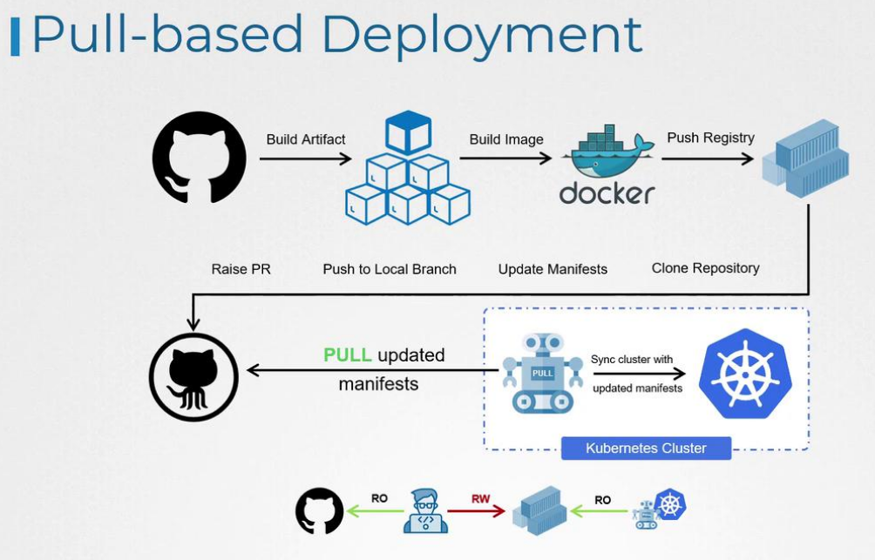

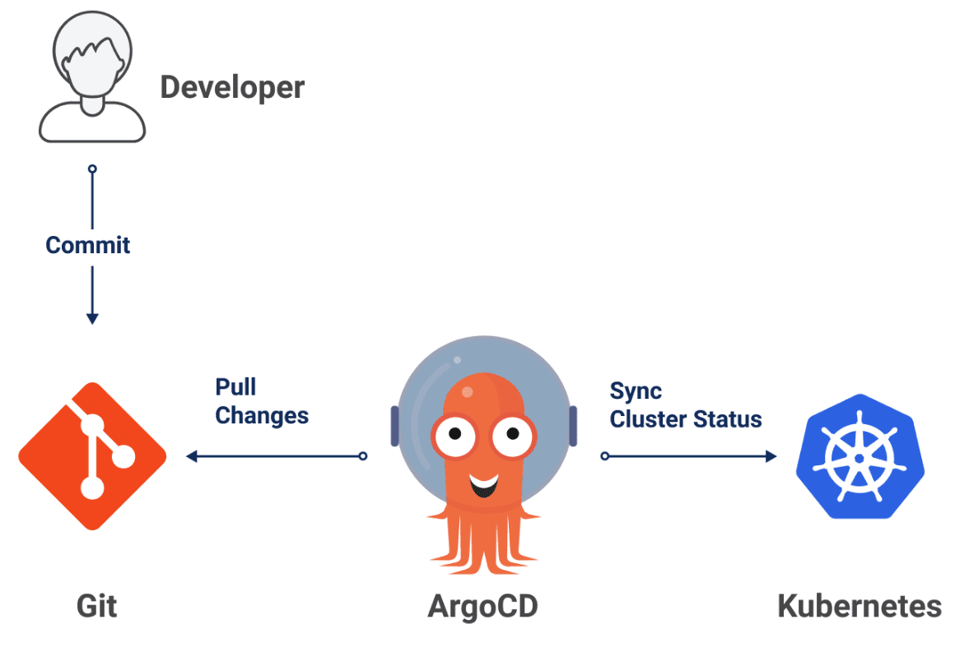
To summarize, GitOps is infrastructure as code combined with version control, pull requests, and CI/CD pipelines.
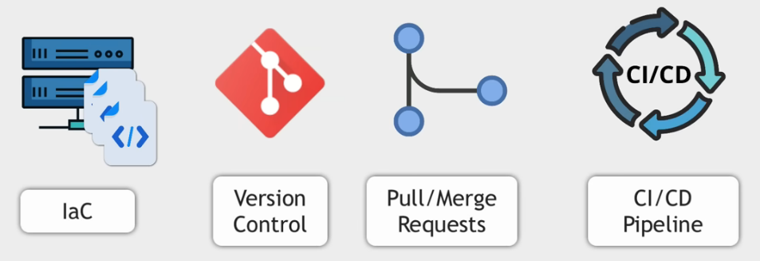
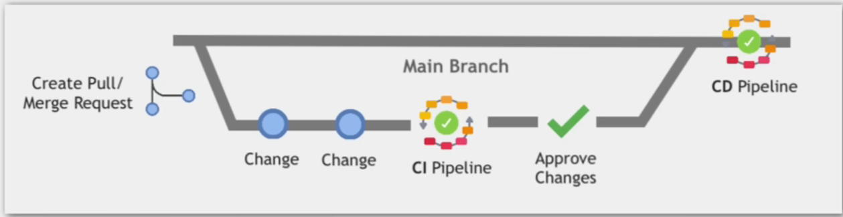

Argo CD
Argo CD is a declarative, GitOps continuous delivery tool for Kubernetes.
Argo CD is a declarative, GitOps continuous delivery (CD) tool specifically designed for Kubernetes. It automates the deployment of applications by continuously monitoring a Git repository (the "single source of truth") and ensuring that the state of the Kubernetes cluster matches the desired state defined in the repository.
Argo CD is a declarative, GitOps continuous delivery tool for Kubernetes that automates the deployment and synchronization of your application states with your Git repositories. It follows the GitOps pattern of using Git repositories as the source of truth for defining the desired application state.
GitOps utilizes Git as a central source for maintaining the desired state of applications and infrastructure, enabling streamlined code development, deployment management, and collaborative workflows.
Argo CD, functioning as a Kubernetes controller, continuously monitors live application states against their desired states defined in Git. You manage operations such as synching using either its web UI or its CLI.
Argo CD is a declarative continuous delivery tool for Kubernetes. It can be used as a standalone tool or as a part of your CI/CD workflow to deliver needed resources to your clusters.

Why Argo CD?
Application definitions, configurations, and environments should be declarative and version controlled. Application deployment and lifecycle management should be automated, auditable, and easy to understand.

Key Takeaways
- Argo CD uses Git repositories as the source of truth for defining the desired application state.
- Argo CD supports configuration management and templating tools, such as Kustomize, Helm, Jsonnet, plain-YAML, and any custom tool configured as a config management plugin.
- Argo CD provides a web UI and a CLI that give you a real-time view and control of your application activity, status, and history. You can also integrate Argo CD with webhooks and other Git providers.

